## Abstract

In this project work an attempt has been made to classify objects using machine learning techniques such as SVM, CNN where python has been used for implementation purpose. We classify images by training, testing and splitting. In this project we have implemented binary class classification but our model can also be used for multiclass classification.

After dividing data and passing through our algorithms we get our outputs. We use data set consisting of 2400 images to check the classification accuracy, precision, roc, f1 score and recall percentages.

# Introduction

For this project “Image classification”, we will see the major problems that occur in the machine learning part of computer vision.

Selecting permanent set of classes or categories and classifying an image is called as image classification. Other computer vision features and challenges like segmentation and object detection can be included in “Image classification”.

For the project, we get started by downloading and viewing our dataset, then we will show how it can be pre-process and get the images ready to be an appropriate input for our machine learning algorithm. In the end, we also will be going to give explanation about our models that we used i.e., “Support Vector Machine (SVM)” and “Convolutional Neural Networks (CNN)” and implement it to do classification.

We will be performing Image classification, which comes under supervised learning problems and algorithms. In this we train a model to recognize different objects using label photo by choosing a set of objects upon which our model will be trained on.

In modern methodologies and modern architectures under the computer vision domain image classification is a major task.

Image classification using machine learning can be very useful when developed under many important fields such as:

* **Medical Imaging / Visualization**: In Medical Imaging it helps professionals and medical experts interpret and get data by medical imaging and to diagnose anomalies at a faster rate.
* **Law Enforcement & Security**: It greatly helps in biometric authentication and to do surveillance.
* **Self-Driving Technology**: Image classification greatly assist in detecting human visual clues, interactions and objects and mimicking oh human beings.
* **Gaming**: It greatly improves virtual reality, augmented reality, 3D gaming and high-quality gaming experiences.
* **Image Restoration & Sharpening**: AI can greatly improve the quality of photos or add popular filters, edits etc.
* **Pattern Recognition:** It greatly helps in classifying and to recognize patterns/ objects in photos and also helps in to understand about them.
* **Image Retrieval**: It collect and even can recognize the images or photos for faster retrieval from very large and complex datasets.

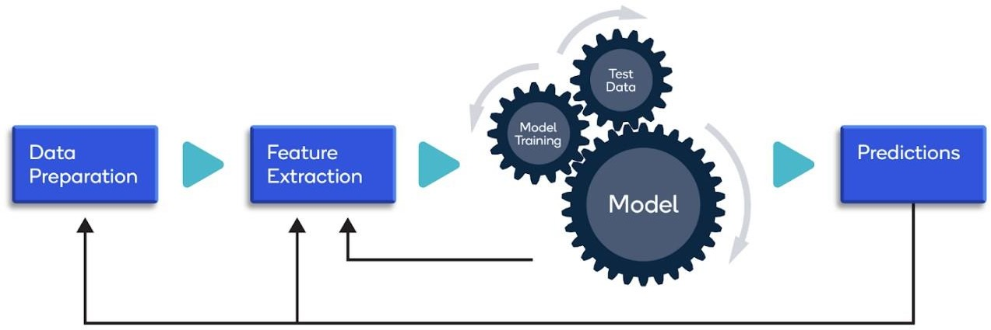

Fig 1: Predicting output using ML based image classification approach.

## Motivation

Since machine learning can be used in various fields so, let’s take an example of Machine learning trained via backpropagation where recently shown to perform well on image classification tasks with lakhs of training images and lot of categories. The feature representation learned by these networks achieves state-of-the-art performance not only on the classification task for which the network was trained, but also on various other visual recognition tasks, for example: classification on various dataset; scene recognition, etc. This capability to generalize to new datasets makes supervised machine learning techniques an attractive approach for generic visual feature learning

# Literature Survey

The technique to classify and categorize different images for identification by analysing many different images of same type from the datasets is known as image classification.

Image classification is a task of image processing in which the images are used to categorized into several groups. For rapid analyse and efficiency we use categorization. Suppose we take an image and characterized it in a place we can move. Semantics categories like sports, outdoor etc are not easy to classify.

Representing the image & learning the models for semantic categories using properties like representations are the two main critical problem for image classification.

It is very difficult to recognizing an object in an image if the image is very occlusion, bad quality, noise or background obstruction is there in it. It also becomes even more of a challenge if the image contains multiple number of objects.

Identifying the features that appears in the photo is main aim of an “image classification”.

There are two categories,

Unsupervised classification’s & Supervised classification’s

In the category of “supervised classification”, human interaction will be required with well-trained datasets.

In the category of “unsupervised classification”, human interaction will not be required at all and the computers can easily manage the task.

For classifying image into semantic categories many algorithms are used for scene classification. Indoor images and outdoor images used edge analysis for their classification. Attributes or features that can be used for differentiation of the texture of an image is required by texture analysis.

Classification Method:

## Support Vector Machine Algorithm: -

We will use two methods in this project, first we will classify the images from the data set using Support Vector Machine Algorithm which is one of the most used algorithms for doing classifications. Support vector machine comes under the method of “supervised learning algorithm” which can easily classify data into multiple classes. Label data are used for classification in support vector machines. Both regression and classification problems can be solved using SVM. A decision boundary or hyper plane is drawn between two or more classes to separate them or we can say classify them.

. It is mainly used for Object Detection & image classification.

## Convolutional Neural Network

Secondly, we will use “convolutional neural network”, CNN is one of the parts for “deep learning” method or “deep neural network”. CNN is mostly applied to analyses and get results for visual imagery problem. If someone think of a neural network or neurons, they think about multiplication of matrixes but that is not the case when we use Conv-Net. A special technique called Convolution is used by Conv-Net.

Here, we are going to use predefined standard dataset available in the internet for doing our Classification. We have collected the datasets using internet and from Kaggle dataset. We have chosen our model to be a “binary classification” model or problem, but the model can also be used for applying “multiclass classification” queries.

Image classification requires the following components to accomplish the task and these are as follows: -

1. The dataset

We’ve downloaded the dataset from Kaggle. The dataset contains the pictures we need for classification.

The task we have to do is to check whether the dataset is well enough balanced or not before we start the classification.

1. Doing the Machine Learning implementation
   * The Support Vector Machine or SVM algorithm is extremely good at classifying things and has been implemented below (using python)

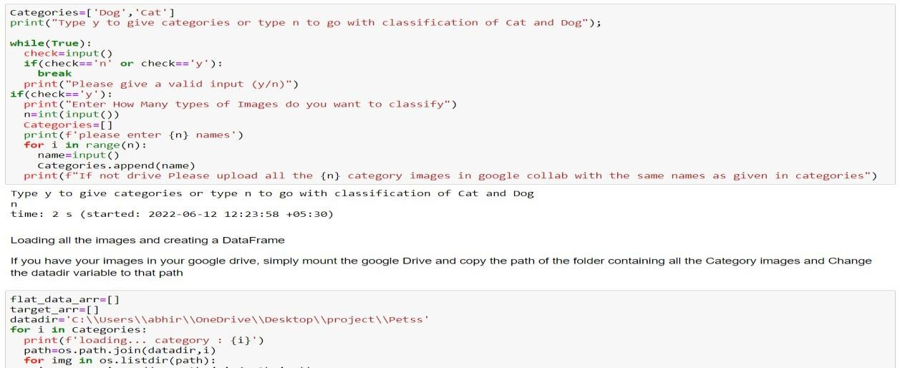

Fig 2: Program Codes of Support vector Machine Algo.

* + The Convolutional Neural Network or CNN is another extremely good algorithm at classifying images which we used in separate section in our project and its snapshot is as follows

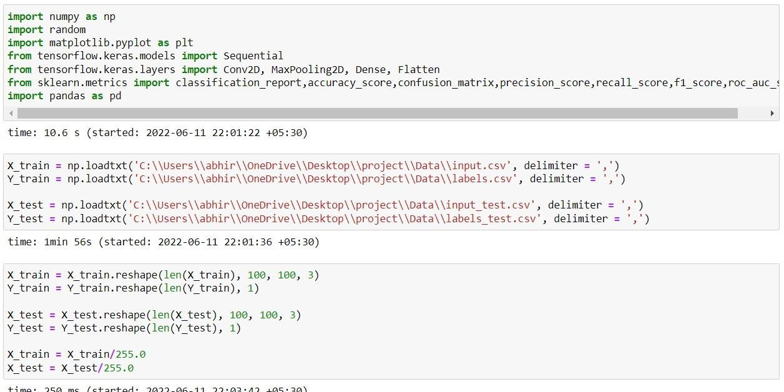

Fig 3: Program codes for Convolutional Neural Network Algo.

# Proposed Methodology

Less than 60%

Making Prediction



Resize data-set and adjust with label

Model Training

More than 60%

Image output

Fig no-4 Flow chart of the proposed model.

In this project work we have done Image classification using machine learning and is done by using Support Vector Machine Algorithm and Convolutional Neural Network.

The algorithm Support Vector Machine is considered as a classification approach, which can easily be handled using various continuation of variables and its different categories. The algorithm creates a various dimensional void and hyperplane so it can differentiate among different class. The hyperplane is created in cooperative way, it can also use to minimize error. It is a supervised learning algorithm it should be used to classify data into separate classes, which further learns from the input provided by us. So, the advantages of this algorithm can be derived in differentiation and separation operation. The creating of boundary of decision should be done which can be used to separate of any two classes of hyperplane which then be used to classify it. It can done the work as an Detection of Objects and classify images.

## How does It work?

It method which it can work is that the segregation of data-set in different possible way can be achieved by it. The separation of these closest known points is called margin. So, the selection of hyper plane with all possible margin between different data-set in Support Vector Machine is the main objective. The algorithm also searches for the highest plane which are included in the following steps:

* The generation of highest planes, which then used to separate is given to different sections in the different possible methods that should be done.
* The selection of the standard side of the highest plane of the highest difference of either the closest data fetching points should be done.

This project work we have done another method that can classify images which is Convolutional Neural Network (CNN), which is another algorithm to classify images. It approves us to derive highest presentation for the images. The classification of images that recognizes it and then can separate the image credentials, The input raw data, is taken to teach the algorithm, so it can derive the basic credentials that is taken by the algorithm for better classification.

The following optical illusions are looked to understand the working of CNN.

It passes from the raw data and then calculate then calculates all the data we entered and derive the dot product value which approves the algorithm to highlight the following features.

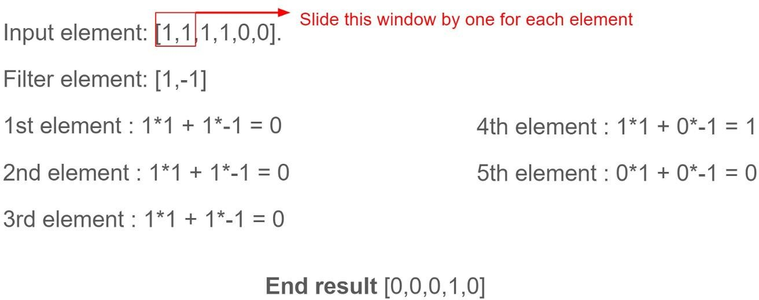

Fig no-5 Dot product working mechanism of Convolutional Neural Network.

We are now looking at the raw input, which will enhance the elements present at the window, which is smaller in size with the dot, then multiplies it with to derive elements, and store the output. Now we will repeat for each operation for each five output elements i.e. [0,0,0,1,0]. So, the output, which can be known through the feature that changes in sequence .So, the derived values has done well to identify the input. Similarly, that can happens for 2D dimension as well.

## Implementation

The following requirements should be fulfilled to implement the

Convolutional Neural Network.

Importing the dataset for the algorithm and separating the inputs for teaching and examining the samples.

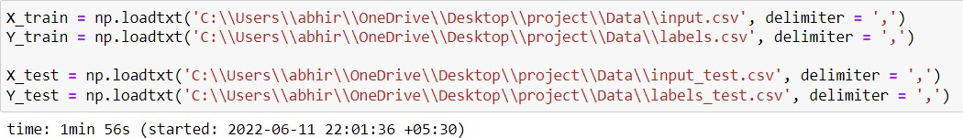

Fig No 6- Program codes for importing the data sets.

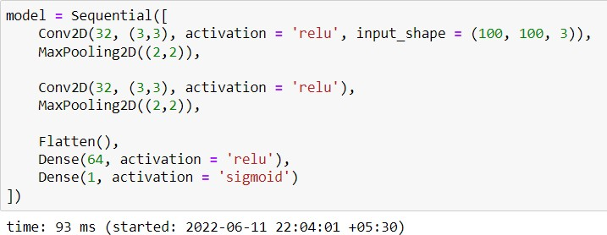Classifying the predictors and target for Convolutional Neural Network.

Fig no 7- Program codes for Classifying data for splitting and testing.

.

After importing input sheet, the following requirements are to be implemented using CNN.

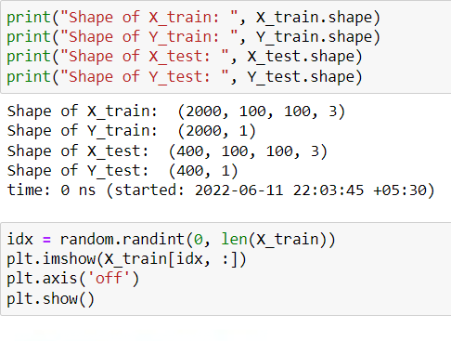

Fig no-8 Program codes for Training and Testing in Convolutional Neural Network.

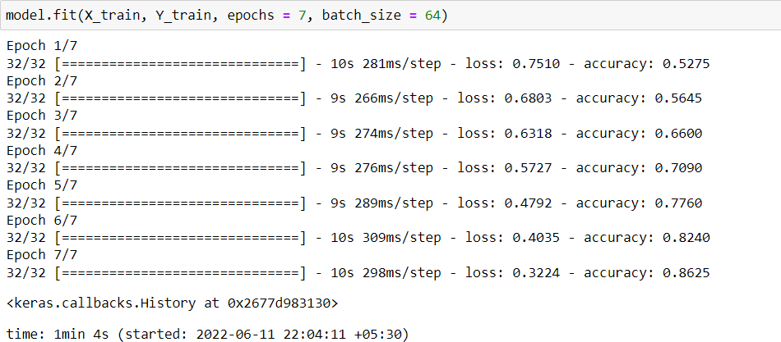Classifying the predictors and target for CNN.

Fig no-9 Program codes of Convolutional Neural Network Algorithm working.

## Implementation and Result

**Using CNN**

In the proposed project we classified data sets of cats and dogs all their data sets are collected from Kaggle data set they were collected compiled using Convolutional Neural Network.

The objects such as Dogs and cats were successfully classified to this program giving an accuracy of 67.5%, Recall: 73%, Area under the curve: 73.7%, Precision: 65.7%, F1 score: 69.1%. The values can be modified for improving the size of the inputs.

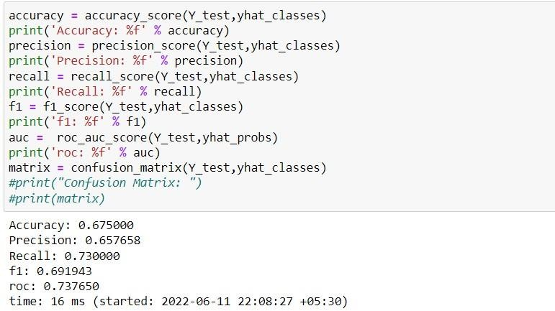

Fig no- 10 Program codes of Predicting accuracy using Convolutional Neural Network.

## Making Prediction

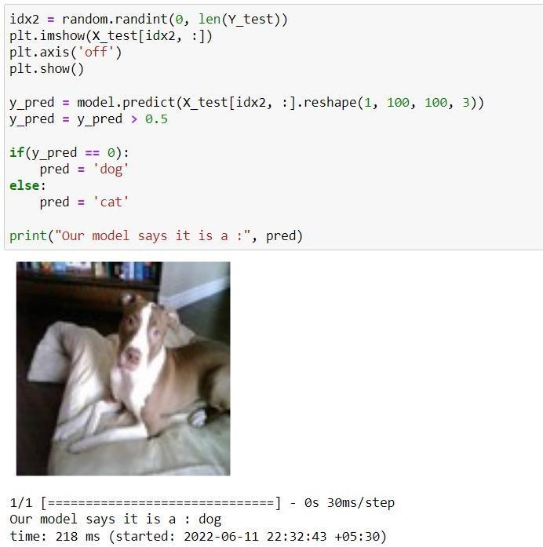

Fig no- 11 C Program codes of Prediction result using Convolutional Neural Network

## Using SVM

In the proposed project we classified data sets of cats and dogs all their data sets are collected from Kaggle data set they were collected compiled using Support Vector Machine Algo.

The objects such as Dogs and cats were successfully classified to this program giving an accuracy of 65.6%, Recall: 68.7%, Area under the curve: 65.6%, Precision: 64.7%, F1 score: 66.6%. The values can be modified for improving the size of the inputs.

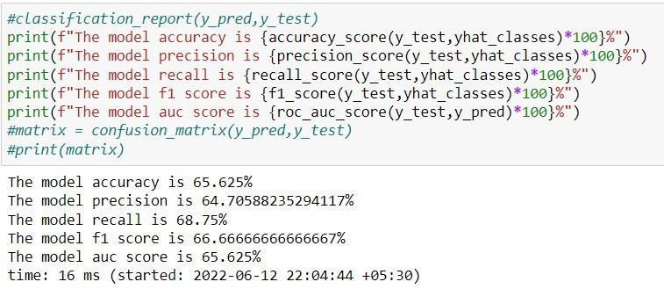

Fig no-12 Program codes of Prediction Accuracy of SVM

## COMPARISION OF SCORES

Accuracy Score between SVM and CNN

68.00%

67.50%

67.00%

66.50%

66.00%

65.50%

65.00%

64.50%

Support Vector Machine

Convolutional Neural Network

Accuracy Score

Precision Score between SVM and CNN

65.80%

65.60%

65.40%

65.20%

65.00%

64.80%

64.60%

64.40%

64.20%

Support Vector Machine

Convolutional Neural Network

Precision Score

Recall Score between SVM and CNN

74.00%

73.00%

72.00%

71.00%

70.00%

69.00%

68.00%

67.00%

66.00%

Support Vector Machine

Convolutional Neural Network

Recall Score

F1 Score between SVM and CNN

69.50%

69.00%

68.50%

68.00%

67.50%

67.00%

66.50%

66.00%

65.50%

65.00%

Support Vector Machine

Convolutional Neural Network

F1 Score

ROC Score between SVM and CNN

76.00%

74.00%

72.00%

70.00%

68.00%

66.00%

64.00%

62.00%

60.00%

Support Vector Machine

Convolutional Neural Network

ROC Score

**Making Prediction**

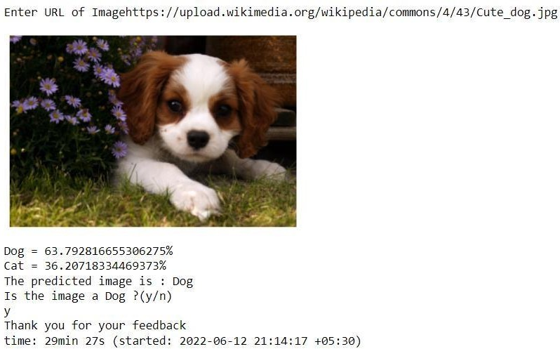

Fig no- 13 Program codes of Prediction result using SVM.

## CONCLUSION

The project entitled “Image Classification using Machine Learning” has been developed to satisfy the requirement that have been completed as far as possible i.e., to predict accuracy, recall, f1 score, ROC percentages with in the time constraint. Support Vector machine, Convolutional Neural Network algorithms have been used to classify images with the objective to classify images using machine learning.

Almost all the mention functionality of the propose system have been incorporated and implemented in the system. The system in what we hope is in user –friendly manner.

It has the freedom of inputting all the important data and queering them a necessary field value. It generates prediction accuracy, f1 score, pression, recall, area under the curve i.e., ROC for data set i.e., Cats and Dogs which help in management decision process.

# Future Scope

This Project is done for image classification using Machine learning. The main objective of this project is to classify different images using different data-set. The out-come of this particular project is directly linked with the conclusions because it can determine whether all desired objectives are achieved successfully or not. It can be concluded the results that are obtained are satisfiable with the predicted outcome. The Support Vector Machine Algorithm (SVM) and Convolutional Neural Network (CNN) algorithms are used to obtain the desired results, in image classification using machine learning project. Implementation of Support Vector Machine Algorithm (SVM) and Convolutional Neural Network (CNN) are done by using Kaggle data sets also gave good results as it is able to simulate, train and classified with up to 62% & 67% percent of accuracy, f1score, ROC, precision and recall value towards the data-set of objects that have become a trained model. Lastly, Python have been used as the programming language throughout this whole project.

## References

[1] Prince, S. .. (2012). *Computer Vision(Models, Learning, and Inference).* London: MODELS, LEARNING AND INFERENCE.

[2] Forsyth, D. A., & Ponce, J. (2012). *COMPUTER VISION:A MODERN APPROACH.* United States of America: Pearson Education.

[3] Sarkar, D., Bali, R., & Sharma, T. ( 2018 ). *Practical Machine With Python(A Problem-Solver’s Guide to*

*Building ).* Bangalore: y Dipanjan Sarkar, Raghav Bali and Tushar Sharma.

[4] <https://www.microsoft.com/en-us/download/details.aspx?id=54765>